LAB 3 – COMPONENT MODELLING & ARCHITECTURAL PATTERN SELECTION
Pharmacy Expiry & Re-order Dispatch Engine
Student | Bhavin G Kamat
SRN | PES1UG24am065
Problem Statement | #15 – Healthcare & Telemedicine
Architecture | Layered Architecture

UML COMPONENT DIAGRAM
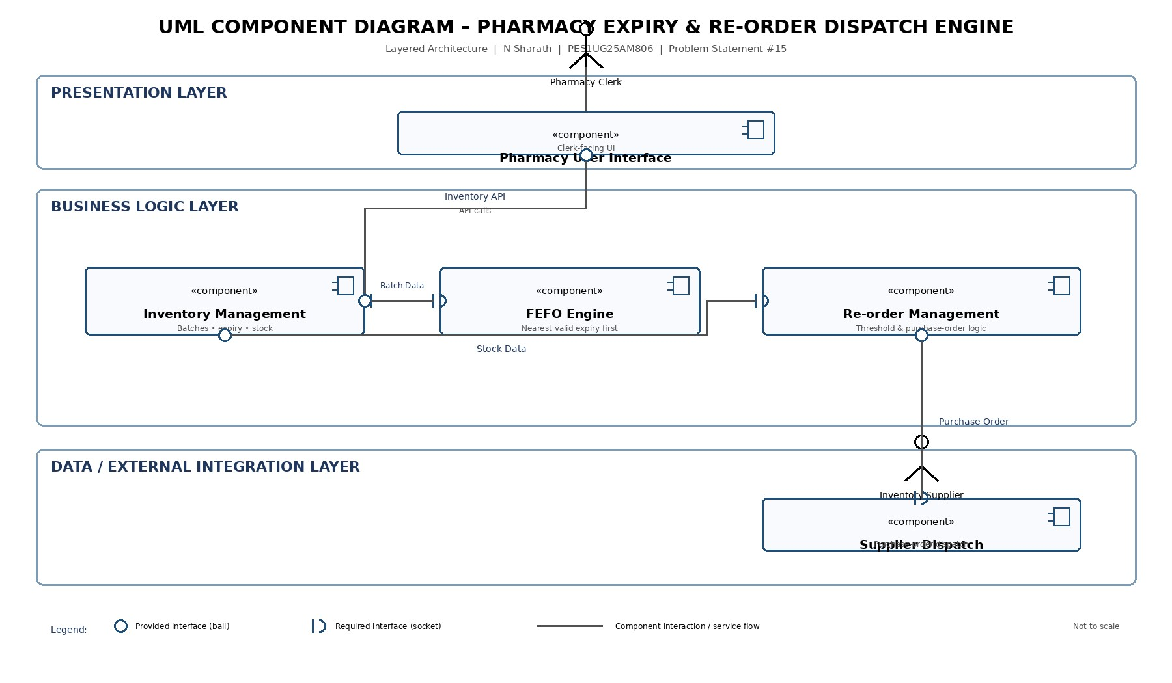
Figure 1. Corrected UML component diagram with five components and four clear component interfaces.
PES University | Software Engineering Lab 3 Page 1

ARCHITECTURE SELECTION & WRITTEN JUSTIFICATION
Architecture Selection: We chose Layered Architecture for the Pharmacy Expiry & Re-order Dispatch Engine.
Architectural Choice: The system is organized into a Presentation Layer, Business Logic Layer, and Data/External Integration Layer. This provides clear separation of responsibilities and maps naturally to pharmacy operations.
Reason 1 – Separation of concerns: User interaction, inventory/FEFO/re-order business rules, and external supplier operations are kept separate. This makes the system easier to understand, test, maintain, and modify.
Reason 2 – Scenario suitability: Batch tracking, FEFO selection, stock-threshold monitoring, and purchase-order dispatch are well-defined business operations. A layered structure supports these operations without the additional operational complexity of microservices.
Security Advantage: Inventory and supplier operations can be controlled at the business layer. The presentation layer does not directly access stored data; requests pass through controlled business services.
Performance Benefit: Inventory and FEFO operations can be optimized within the business layer and database access can be tuned independently. This avoids unnecessary distributed-service network overhead for this scenario.
Architecture Comparison: Layered Architecture was selected over Microservices and Client-Server. Microservices offer independent scaling and fault isolation but introduce operational complexity, network latency, and data-consistency challenges. Client-Server offers centralized control but has single-point-of-failure and scalability limitations.
Component Mapping: Pharmacy User Interface → Inventory Management → FEFO Engine / Re-order Management → Supplier Dispatch. Interfaces shown are Inventory API, Batch Data, Stock Data, and Purchase Order.
Conclusion: The proposed layered component architecture provides modularity, clear interfaces, controlled data access, and suitable performance for the assigned pharmacy system.
Hemant D C | PES1UG24AM119
PES University | Software Engineering Lab 3 Page 2

